PL/SQL PROGRAMMING

WEEK 1:
MANDATORY EXERCISES:
EXERCISE 1:

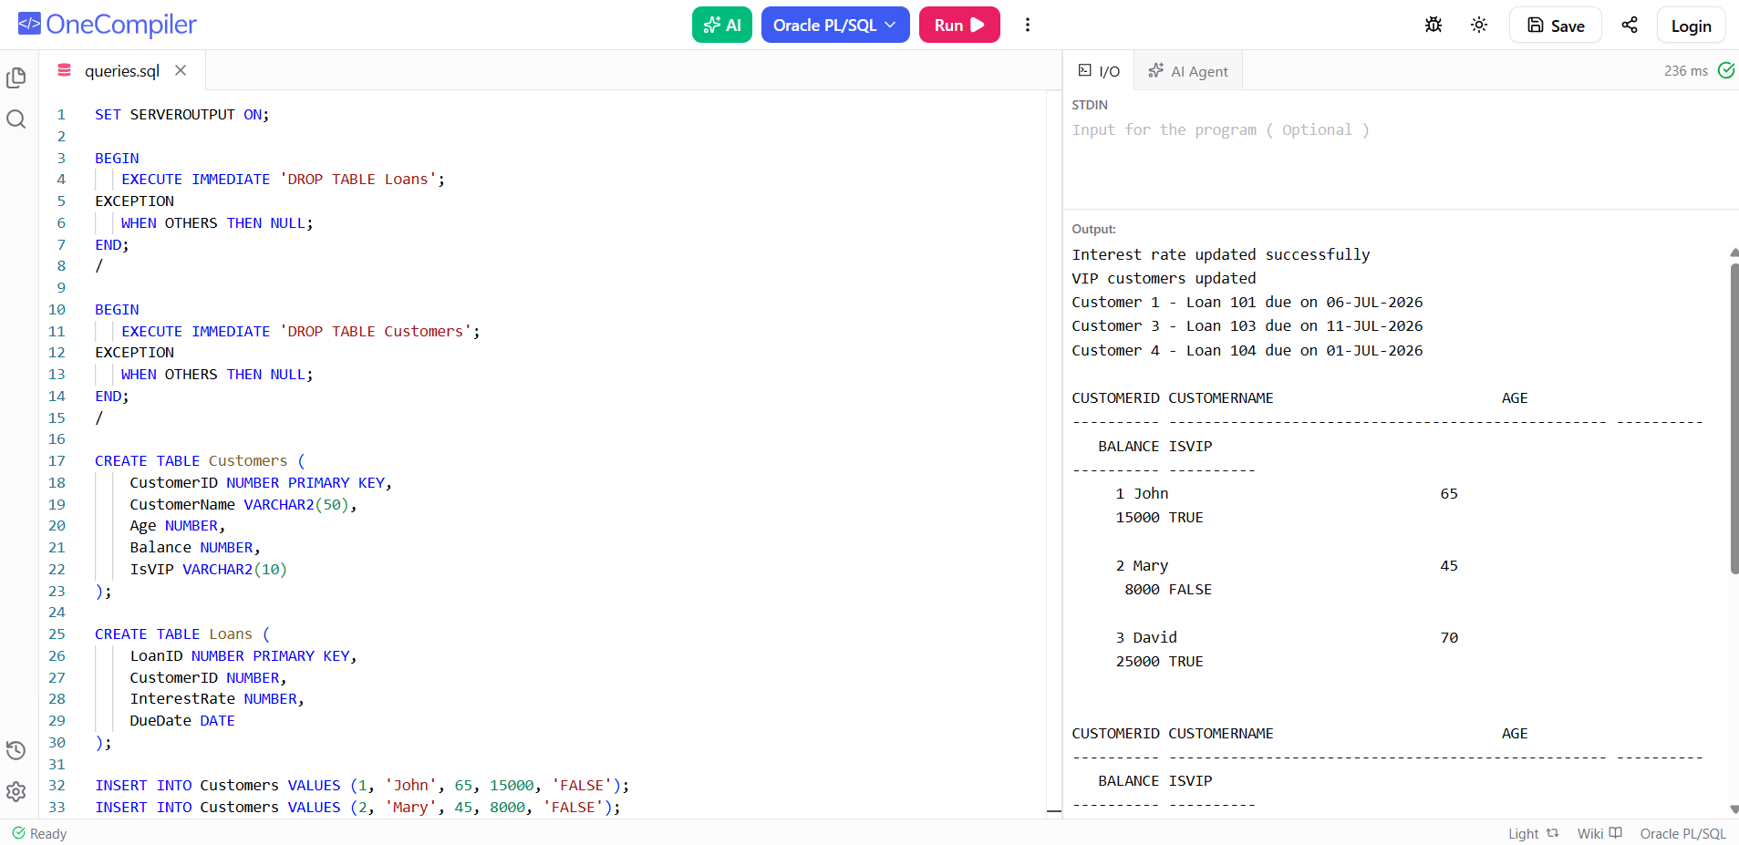

EXERCISE 3:

